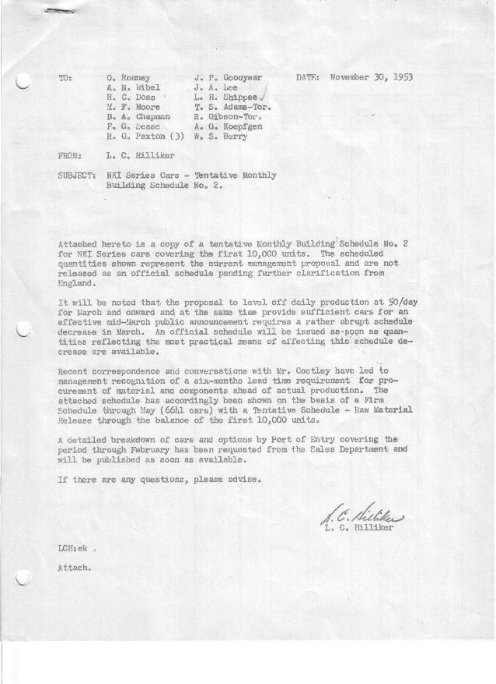

FORM PLAN 68 REV. 9-40-N.K.P TENTATIVE SCHEDULE - UNAPPROVED PRINTED IN U.S.A

SCHEDULE NO. ______2_________ DATE November 27, 1953 MONTHLY BUILDING SCHEDULE APPROVED____________________________________DATE________________ REVISION NO. ________________ DATE ________________ PRODUCT APPROVED____________________________________DATE_________________
NKI Series Cars – Austin Motors Co., Ltd., - England

DESCRIPTION | BUILT  ACT□EST  THRU  10-31-53 | FIRM BUILDING SCHEDULE  (FABRICATED MATERIAL RELEASE) |  |  |  |  |  |  |  |  |  |  |  |  |  |  |  | TENTATIVE SCHEDULE  (RAW MATERIAL RELEASED) |  |  | GRAND  TOTAL
DESCRIPTION | BUILT  ACT□EST  THRU  10-31-53 | MONTH November, 1953  DAYS |  |  |  | MONTH December, 1953  DAYS |  |  | MONTH January, 1954  DAYS |  |  | MONTH February, 1954  DAYS |  |  | MONTH March, 1954  DAYS |  |  |  |  |  | GRAND  TOTAL
DESCRIPTION | BUILT  ACT□EST  THRU  10-31-53 | DAILY |  | MONTH | CUM’L  TOTAL | DAILY | MONTH | CUM’L  TOTAL | DAILY | MONTH | CUM’L  TOTAL | DAILY | MONTH | CUM’L  TOTAL | DAILY | MONTH | CUM’L  TOTAL |  |  |  | GRAND  TOTAL
NKI Series
Hard-Top Convertible | 65 |  |  | 197 | 262 |  | 425 | 687 |  | 425 | 1112 |  | 634 | 1746 |  | 575 | 2321
Soft-Top Convertible | 0 |  |  | 8 | 8 |  | 75 | 83 |  | 625 | 708 |  | 1037 | 1745 |  | 575 | 2320
Total | 65 |  |  | 205 | 270 | 24 | 500 | 770 | 50 | 1050 | 1820 | 89 | 1671 | 3491 | 50 | 1150 | 4641
Over/(Under) Sched. 1, Rev. 2 | (575) |  |  | (635) | (1210) |  | (485) | (1695) |  | (40) | (1735) |  | 631 | (1104) |  | (378) | (1482)
 |  | April, 1954 |  |  |  | May, 1954 |  |  | June, 1954 |  |  | TENTATIVE SCHEDULE – RAW  July, 1954 |  |  | August 1954
Hard-Top Convertible |  |  | 475 |  | 2796 |  | 525 | 3321 |  | 475 | 3796 |  | 425 | 4221 |  | 400 | 4621
Soft-Top Convertible |  |  | 475 |  | 2795 |  | 525 | 3321 |  | 475 | 3795 |  | 425 | 4220 |  | 400 | 4620
Total |  | 50 | 950 |  | 5591 | 50 | 1050 | 6641 | 50 | 950 | 7591 | 50 | 850 | 8441 | 50 | 800 | 9241
Over/(Under) Sched. 1, Rev. 2 |  |  | (427) |  | (1909)
MATERIAL RELEASED
September, 1954
Hard-Top Convertible |  |  | 379 |  | 5000 |  |  |  |  |  |  |  |  |  |  |  |  |  |  |  | 5000
Soft-Top Convertible |  |  | 380 |  | 5000 |  |  |  |  |  |  |  |  |  |  |  |  |  |  |  | 5000
Total |  | 50 | 759 |  | 10,000 |  |  |  |  |  |  |  |  |  |  |  |  |  |  |  | 10,000
Over/(Under) Sched. 1, Rev. 2

